**Cloud Computing Lab**

**Safa Jahangir**

**BSE-V B**

**2023-BSE-056**

**LAB 01**

**Task 1:**

Installation of Ubuntu Server inside **VMware Workstation Pro**.

**1. Install VMware Workstation Pro**

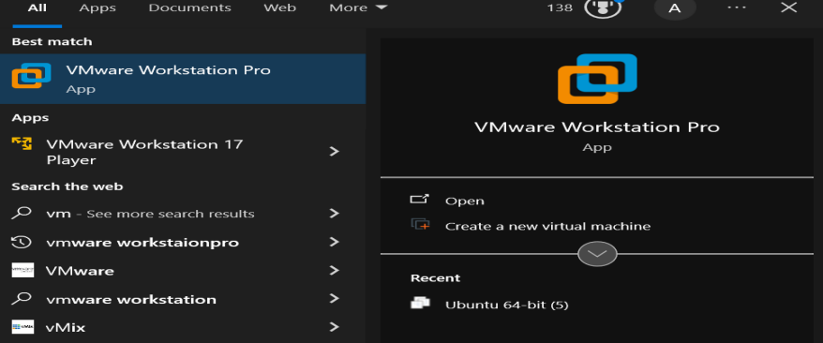

**2. Download Ubuntu Server ISO**

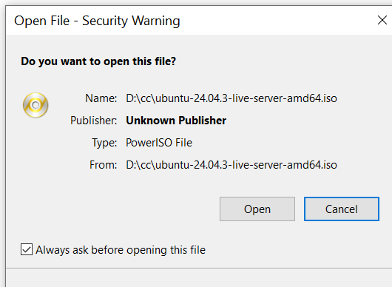

**3. Create a new virtual machine in VMware**

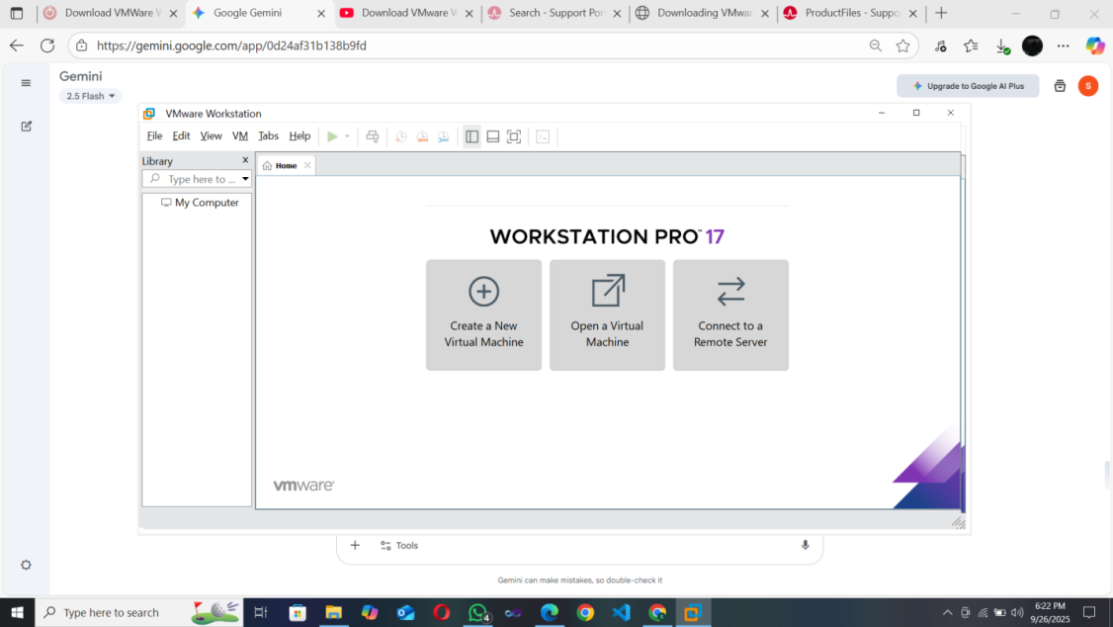

**4. Start the virtual machine**

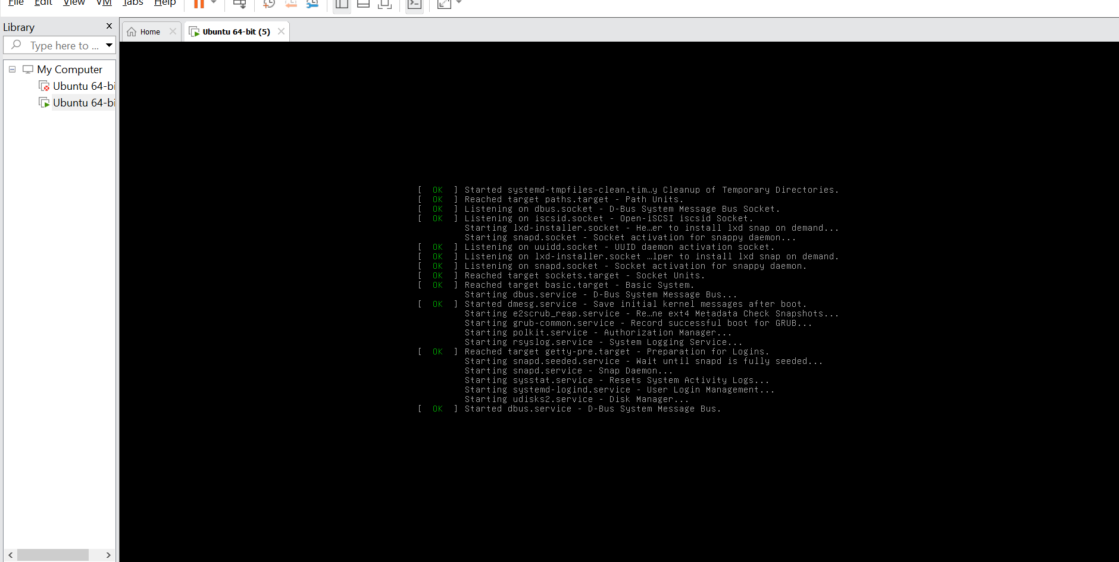

**5. Choose your install**

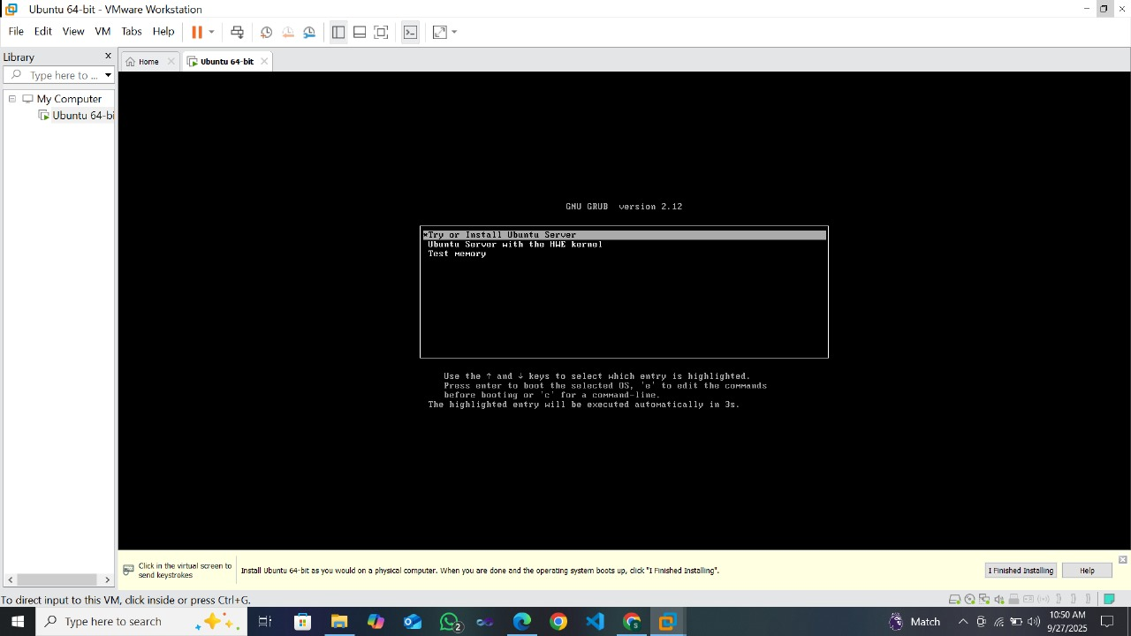

**6. Login after completing Installing**

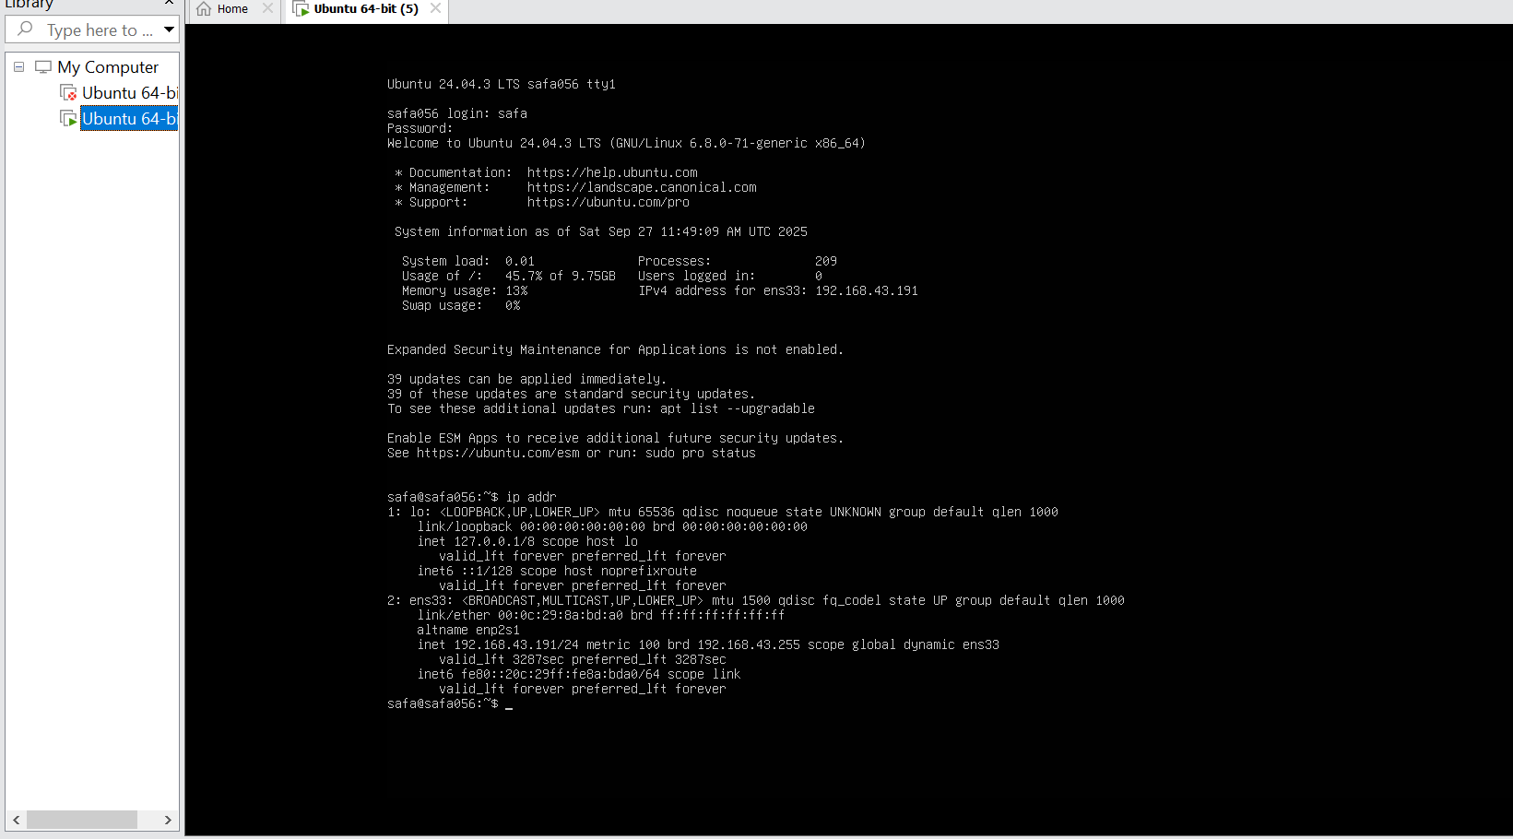

**7. Find the IP address of your Ubuntu Server**



**8. Connect via SSH from Windows**

